Model 2 : Linear Regression Model
Objective and Variables
The objective of Model 2 is to predict the number of goals scored by an individual team in a FIFA World Cup 2026 match. The dataset contains 208 values..
There are 8 explanatory variables. It is selected to represent team performance, experience and other characteristics.
- Team xG: Historical expected goals per match.
- Average Goals Scored: Average goals scored in the team's previous international matches.
- Average Age: Average age of the national squad.
- Transfers 2025: International player transfer activity during 2025.
- Coach Salary: Estimated annual salary of the national team coach in euros.
- FIFA Ranking: Team's FIFA ranking from April 2026.
- Forward Goal Rate: International goals relative to international appearances for forward players.
- Squad Goals: Total international goals scored by players in the squad.

Data Preparation and Exploratory Analysis
The group members collected the datasets and useful datasets were combined to make the final dataset. Python coding was used to check the data structure, missing values, duplicate records and numerical values.
The final dataset contained 208 rows and 16 columns, with no duplicate team-match records. Three negative xG entries for Panama were identified and it is treated as missing values. Median imputation was applied using the training dataset.
A correlation heatmap was used to check how the variables were related to goals scored. FIFA ranking had a negative correlation (−0.37), while forward goal rate (0.35) and average goals scored (0.30) had positive correlations. The VIF results were below 5 for all eight variables, so all were kept in the model.
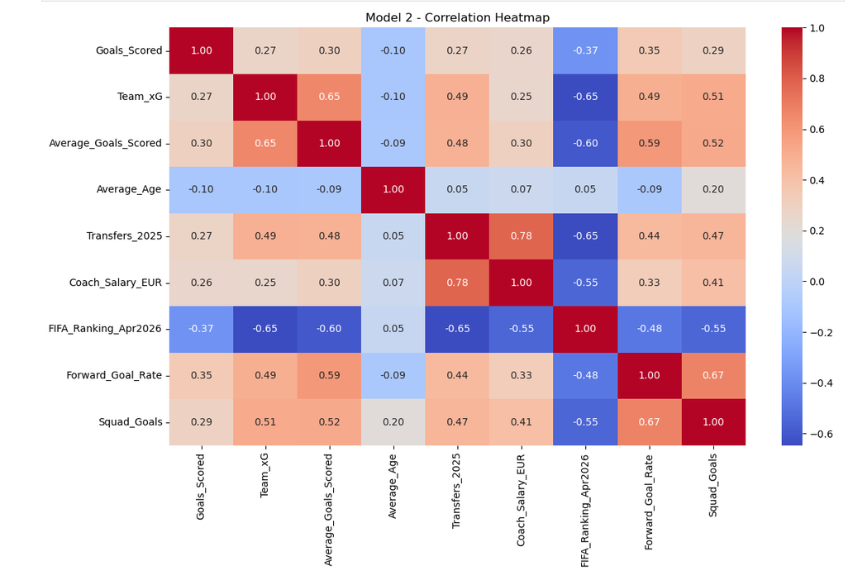Figure 1. Correlation heatmap showing relationships between goals scored and the explanatory variables.
Methodology
Multiple linear regression was performed in Python using 208 observations and eight explanatory variables. An 80/20 train-test split was used, keeping both teams from each match together. Model performance was checked using MAE, RMSE, R² and five-fold cross-validation.
Regression Results
The model performed better than the baseline, with an average prediction error of approximately one goal.

The prediction accuracy is still limited.
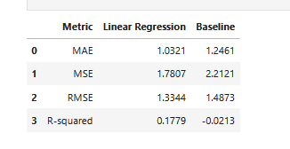
Figure 2. Regression performance and comparison with the baseline model.
Model Improvements and Visualisations
Standardisation did not change the model's performance. Log transformation of Transfers 2025 and Coach Salary slightly reduced accuracy (R² = 0.176). Therefore, the original regression model was retained.
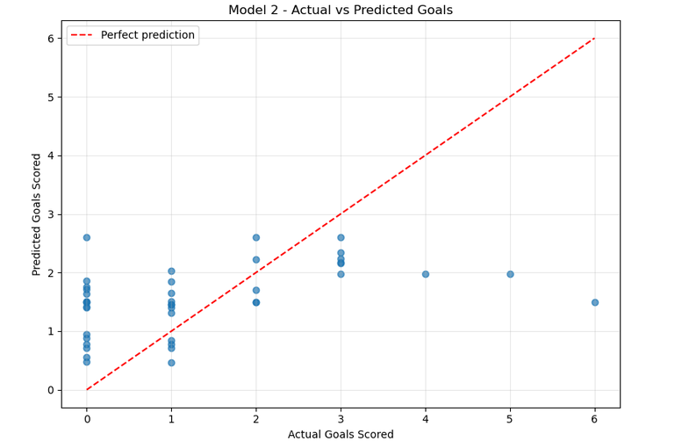
Figure 3. Comparison between actual goals scored and predicted goals.
The model generally predicted too many goals for teams scoring zero and too few for teams scoring higher totals.
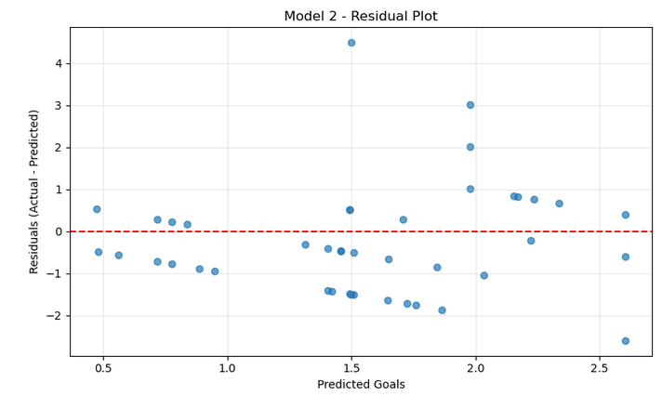Figure 4. Residual plot showing the errors between actual and predicted goals.
Conclusion
Model 2 predicted goals better than the baseline, but its low R² shows that accurate goal prediction remains difficult. Some historical data sources also require further verification.
Data sources used:
https://footystats.org/
https://fixturedownload.com

